Day 12 - 31th July 2026

DBMS
Task 1:
Why is there a need for DBMS?
A Database Management System (DBMS) is needed to efficiently store, organize, manage, and retrieve large amounts of data. Before DBMS, data was stored in separate files, which led to many problems such as duplication, inconsistency, and difficulty in accessing data.
Need for DBMS
- Reduces Data Redundancy
  - Eliminates unnecessary duplication of data.
  - Stores data in a centralized manner.
- Ensures Data Consistency
  - When data is updated, changes are reflected throughout the database.
  - Prevents conflicting versions of the same data.
- Provides Data Security
  - Restricts unauthorized access through user authentication and permissions.
  - Protects sensitive information.
- Facilitates Easy Data Access
  - Allows users to retrieve data quickly using queries.
  - Supports efficient searching and reporting.
- Improves Data Integrity
  - Maintains accuracy and reliability of data through constraints and validation rules.
- Supports Data Sharing
  - Multiple users can access and work with the same database simultaneously.
- Provides Backup and Recovery
  - Enables recovery of data in case of system failures, crashes, or accidental deletion.
- Ensures Concurrency Control
  - Manages simultaneous access by multiple users without causing conflicts.
- Saves Time and Effort
  - Automates many data management tasks, increasing productivity and efficiency.

Task 2:
Why not traditional DBMS?
Traditional file systems have several drawbacks that make data management difficult:
- Data redundancy: Same data may be stored in multiple files.
- Data inconsistency: Updates in one file may not reflect in others.
- Poor security: Limited control over who can access data.
- Difficult data retrieval: Searching and updating data can be time-consuming.
- No proper backup and recovery: Data loss is harder to prevent and recover from.
- Limited data sharing: Multiple users accessing data simultaneously can create conflicts.
Because of these limitations, DBMS is preferred as it provides better organization, security, consistency, and efficient data management.

Task 3:
Explain the concept of data independence in DBMS.
Data independence is the ability to change the database structure at one level without affecting the next higher level. It allows modifications to the database without requiring changes to application programs.
There are two types of data independence:
- Physical Data Independence
  - Changes in the physical storage of data do not affect the logical structure.
  - Example: Changing the storage device or indexing method without modifying applications.
- Logical Data Independence
  - Changes in the logical structure do not affect user views or application programs.
  - Example: Adding a new column to a table without impacting existing applications.

Task 4:
What are the different types of database models (hierarchical, network, relational, object-oriented)?
1. Hierarchical Model
- Organizes data in a tree-like structure with parent-child relationships.
- Each child has only one parent.
- Example: Organization charts.
2. Network Model
- Organizes data as a network of records connected by links.
- A child can have multiple parents.
- More flexible than the hierarchical model.
3. Relational Model
- Stores data in tables (rows and columns).
- Relationships are established using keys.
- Most widely used model (e.g., MySQL, Oracle, SQL Server).
4. Object-Oriented Model
- Stores data as objects, similar to object-oriented programming.
- Supports complex data types and inheritance.
- Commonly used in applications with multimedia and complex data structures.

Task 5:
Describe concurrency control in DBMS. Why is it important?
Concurrency control is the process of managing simultaneous access to a database by multiple users without causing data inconsistency or conflicts.
For example, if two users try to update the same bank account at the same time, concurrency control ensures that the data remains accurate and no update is lost.

Task 6:
What are indexes in DBMS? How do they improve query performance?
Indexes are special data structures that help the database locate data quickly without scanning the entire table. They work similarly to an index in a book, which helps you find information faster.
- Speed up data retrieval by reducing the number of records the database must search.
- Improve query efficiency for operations like SELECT, WHERE, ORDER BY, and JOIN.
- Reduce disk access time, leading to faster response times.
- Help databases handle large volumes of data more efficiently.

Task 7:
Explain deadlock in DBMS. What are the strategies for deadlock prevention and detection?
A deadlock occurs when two or more transactions are waiting for each other to release resources, and none of them can proceed.
Example:
- Transaction T1 locks Resource A and waits for Resource B.
- Transaction T2 locks Resource B and waits for Resource A.
- Both transactions keep waiting forever, causing a deadlock.

Deadlock Prevention Strategies
- Resource Ordering: Allocate resources in a fixed order to avoid circular waiting.
- Wait-Die Scheme: Older transactions wait, while younger ones are rolled back.
- Wound-Wait Scheme: Older transactions force younger ones to roll back.
- Timeout Method: Transactions waiting too long are aborted and restarted.
Deadlock Detection Strategies
- Wait-For Graph: The DBMS creates a graph of transactions and checks for cycles. A cycle indicates a deadlock.
- Periodic Detection: The system regularly scans for deadlocks and identifies affected transactions.
- Recovery: Once a deadlock is detected, one or more transactions are rolled back to break the deadlock.

Task 8:
What do you understand by Relational model?
The Relational Model is a database model that stores data in the form of tables (relations) consisting of rows (tuples) and columns (attributes).
- Each row represents a record.
- Each column represents a data field.
- Tables are related to each other using keys such as Primary Keys and Foreign Keys.
Example
Student Table
Student_ID | Name
101 | Ravi
102 | Priya

Course Table
Course_ID | Course_Name
C01 | DBMS
C02 | Java
Data can be linked between tables through relationships.
Advantages
- Simple and easy to understand.
- Reduces data redundancy.
- Maintains data integrity and consistency.
- Supports powerful SQL queries for data retrieval.

Task 9:
Specify key terms that you encounter in RDBMS. Give brief explanation
- Table (Relation): A collection of related data organized in rows and columns.
- Row (Tuple): A single record in a table.
- Column (Attribute): A field that stores a specific type of information.
- Primary Key: A column (or set of columns) that uniquely identifies each record in a table.
- Foreign Key: A column that creates a relationship between two tables by referencing the primary key of another table.
- Candidate Key: An attribute or set of attributes that can uniquely identify a record and can become the primary key.
- Super Key: Any attribute or combination of attributes that uniquely identifies a record.
- Composite Key: A key formed using two or more attributes to uniquely identify a record.
- Schema: The overall structure or design of the database.
- SQL (Structured Query Language): The language used to create, manage, and query databases.
- Null Value: Represents missing, unknown, or undefined data.
- Constraint: Rules applied to columns to maintain data integrity (e.g., NOT NULL, UNIQUE).

Task 10:
What are different types of keys in RDBMS?
Explain using diagrams ..
1. Primary Key (PK)
- Uniquely identifies each record in a table.
- Cannot contain NULL values.
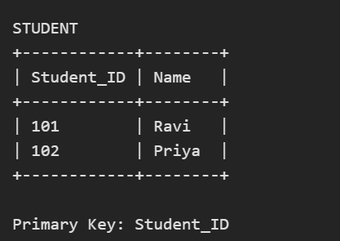

2. Foreign Key (FK)
- Creates a relationship between two tables.
- References the Primary Key of another table.

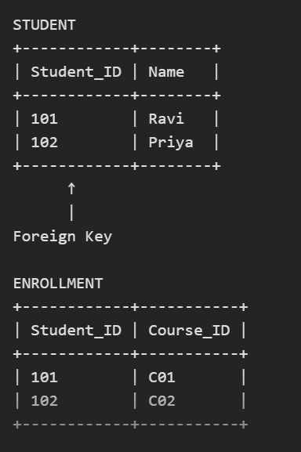

3. Candidate Key
- Attribute(s) that can uniquely identify a record.
- One candidate key is chosen as the Primary Key.

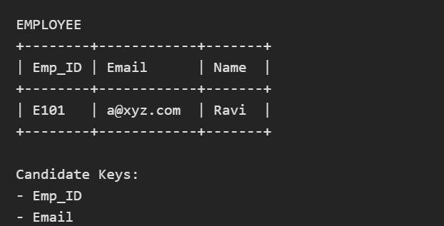
4. Super Key
- Any attribute or combination of attributes that uniquely identifies a record.

EMPLOYEE

Super Keys:
- Emp_ID
- Email
- (Emp_ID, Name)
- (Email, Name)
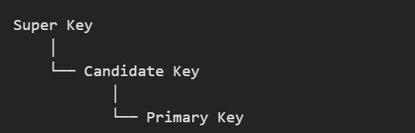

5. Composite Key
- Formed using two or more attributes together.


6. Alternate Key
- Candidate keys that are not selected as the Primary Key.
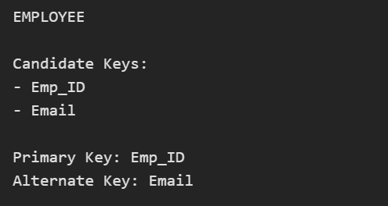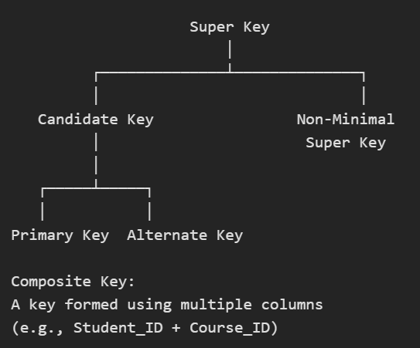

Task 11:
As you know diff keys in RDBMS what is the difference between primary key, foreign key, and unique key?
Key | Purpose | Uniqueness | NULL Values
Primary Key | Uniquely identifies each record in a table. | Must be unique. | Not allowed.
Foreign Key | Creates a relationship between two tables. | Can have duplicate values. | Allowed (unless restricted).
Unique Key | Ensures all values in a column are unique. | Must be unique. | Can contain NULL values (DBMS-dependent).

Task 12:
How does transaction management work in DBMS? Give an example of commit and rollback
Transaction Management is the process of ensuring that database transactions are executed completely and correctly. A transaction is a set of operations performed as a single unit of work.
It follows the ACID properties:
- Atomicity: Either all operations occur or none.
- Consistency: Database remains valid before and after the transaction.
- Isolation: Transactions do not interfere with each other.
- Durability: Committed changes are permanently saved.

Task 13:
What is normalization? Why is it necessary in database design?
Normalization is the process of organizing data in a database to reduce redundancy (duplicate data) and improve data integrity. It involves dividing large tables into smaller, related tables and defining relationships between them.
Why is Normalization Necessary?
Normalization is important because it:
- Reduces Data Redundancy
  - Eliminates unnecessary duplication of data.
  - Saves storage space and makes data management easier.
- Improves Data Integrity
  - Ensures that data is stored consistently throughout the database.
  - Prevents inconsistencies caused by duplicate records.
- Avoids Update Anomalies
  - Changes to data need to be made only once.
  - Reduces the risk of errors during updates.
- Prevents Insertion and Deletion Anomalies
  - Makes it easier to add new data without affecting existing records.
  - Prevents accidental loss of important information when deleting records.
- Enhances Database Efficiency
  - Creates a well-structured database that is easier to maintain and query.

Task 14:
What do you understand by 1nf? Explain with an example
Each column contains atomic (single) values only.
There are no repeating groups or multiple values in a single cell.
Each row is unique.

Example
Table Not in 1NF
Student_ID | Student_Name | Subjects
101 | Ravi | Math, Science
102 | Priya | English, Computer
The Subjects column contains multiple values in a single cell, so the table is not in 1NF.
Converted to 1NF
Student_ID | Student_Name | Subject
101 | Ravi | Math
101 | Ravi | Science
102 | Priya | English
102 | Priya | Computer
Now each cell contains only one value, and the table satisfies First Normal Form (1NF).

Task 15:
What do you understand about 2NF? Explain with an example.
Second Normal Form (2NF) is a level of database normalization that helps reduce data redundancy.
A table is in 2NF if:
- It is already in First Normal Form (1NF).
- Every non-key attribute is fully dependent on the entire primary key, not just part of it.
Example
Table in 1NF but Not in 2NF
Student_ID | Course_ID | Student_Name | Course_Name
101 | C01 | Ravi | Database
101 | C02 | Ravi | Java
102 | C01 | Priya | Database
Composite Primary Key: (Student_ID, Course_ID)
Problems:
- Student_Name depends only on Student_ID.
- Course_Name depends only on Course_ID.
These are partial dependencies, so the table is not in 2NF.

Converting to 2NF
Student Table
Student_ID | Student_Name
101 | Ravi
102 | Priya
Course Table
Course_ID | Course_Name
C01 | Database
C02 | Java
Enrollment Table
Student_ID | Course_ID
101 | C01
101 | C02
102 | C01
Now:
- Student_Name depends entirely on Student_ID.
- Course_Name depends entirely on Course_ID.
- Enrollment table contains only the relationship between students and courses.
Therefore, all non-key attributes are fully dependent on their respective primary keys, and the database is in Second Normal Form (2NF).

Task 16:
What do you understand by 3 nf ? Explain with an example
Third Normal Form (3NF) is a database normalization rule used to eliminate transitive dependencies and further reduce data redundancy.
A table is in 3NF if:
- It is already in Second Normal Form (2NF).
- No non-key attribute depends on another non-key attribute.
- Every non-key attribute depends only on the primary key.

Example
Table in 2NF but Not in 3NF
Student_ID | Student_Name | Department_ID | Department_Name
101 | Ravi | D01 | Computer Science
102 | Priya | D02 | Electronics
103 | Anil | D01 | Computer Science
Primary Key: Student_ID
Here:
- Student_Name depends on Student_ID.
- Department_ID depends on Student_ID.
- But Department_Name depends on Department_ID, not directly on Student_ID.
This is called a transitive dependency, so the table is not in 3NF.

Converting to 3NF
Student Table
Student_ID | Student_Name | Department_ID
101 | Ravi | D01
102 | Priya | D02
103 | Anil | D01
Department Table
Department_ID | Department_Name
D01 | Computer Science
D02 | Electronics
Now:
- Student information is stored in the Student table.
- Department information is stored in the Department table.
- Every non-key attribute depends only on its table's primary key.
Therefore, the database is in Third Normal Form (3NF).

Task 17:
What do you understand by joins? Explain all joins with examples
A Join is an SQL operation used to combine rows from two or more tables based on a related column between them.
Joins are used when data is stored in multiple tables and we want to retrieve related information from those tables.
Example Tables
Student Table
Student_ID | Student_Name | Dept_ID
101 | Ravi | D01
102 | Priya | D02
103 | Anil | D03
Department Table
Dept_ID | Department_Name
D01 | Computer Science
D02 | Electronics
D04 | Mechanical

1. INNER JOIN
Returns only the rows that have matching values in both tables.
Result
Student_ID | Student_Name | Department_Name
101 | Ravi | Computer Science
102 | Priya | Electronics
Explanation:
Only matching department IDs (D01 and D02) are displayed.

2. LEFT JOIN (LEFT OUTER JOIN)
Returns all records from the left table and matching records from the right table.
Result
Student_ID | Student_Name | Department_Name
101 | Ravi | Computer Science
102 | Priya | Electronics
103 | Anil | NULL
Explanation:
All students are shown. Since D03 does not exist in the Department table, NULL is returned.

3. RIGHT JOIN (RIGHT OUTER JOIN)
Returns all records from the right table and matching records from the left table.
Result
Student_ID | Student_Name | Department_Name
101 | Ravi | Computer Science
102 | Priya | Electronics
NULL | NULL | Mechanical
Explanation:
All departments are displayed. Since D04 has no student, NULL values appear for student details.

4. FULL JOIN (FULL OUTER JOIN)
Returns all records when there is a match in either table.
Result
Student_ID | Student_Name | Department_Name
101 | Ravi | Computer Science
102 | Priya | Electronics
103 | Anil | NULL
NULL | NULL | Mechanical
Explanation:
Includes matched records and unmatched records from both tables.

5. CROSS JOIN
Returns the Cartesian product of both tables.
Result
Student_Name | Department_Name
Ravi | Computer Science
Ravi | Electronics
Ravi | Mechanical
Priya | Computer Science
Priya | Electronics
Priya | Mechanical
Anil | Computer Science
Anil | Electronics
Anil | Mechanical
Explanation:
Every student is combined with every department.
Number of rows = 3 × 3 = 9 rows.

6. SELF JOIN
A table is joined with itself.
Example Employee Table
Emp_ID | Employee_Name | Manager_ID
1 | Rahul | NULL
2 | Amit | 1
3 | Neha | 1
Result
Employee | Manager
Rahul | NULL
Amit | Rahul
Neha | Rahul
Explanation:
The table is joined with itself to find employees and their managers.

Summary of Joins
Join Type | Description
INNER JOIN | Returns only matching rows from both tables
LEFT JOIN | Returns all rows from the left table and matching rows from the right table
RIGHT JOIN | Returns all rows from the right table and matching rows from the left table
FULL JOIN | Returns all rows from both tables
CROSS JOIN | Returns all possible combinations of rows
SELF JOIN | Joins a table with itself

